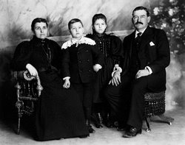
John William Lambert (January 29, 1860 – May 20, 1952) was an American automotive pioneer, inventor, and automobile manufacturer.

The Buckeye gasoline buggy or Lambert gasoline buggy was the first practical gasoline automobile available for sale in America, according to automobile historians.

Lambert initially designed and built his "horseless carriage" gasoline automobile in 1890. He successfully tested it in January 1891 inside an 80-foot farm implement showroom he owned in Ohio City.

Lambert's three-wheeled surrey-top gasoline-powered buggy was his design. It had a single cylinder, four- stroke engine. This, the Buckeye gasoline buggy, was a one-seat tricycle with large rear wheels.
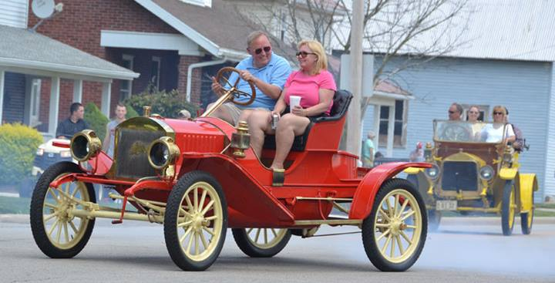
General Information

Jason Parrish (567) 259-9460

Brenda Weaver (419) 965-2000

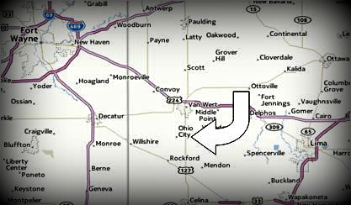
Ralph Riley (419) 965-2443

Poker/ Monte Carlo

Josh Agler (567) 259-9941

Parade

Rob Dorsett (419) 965-2954

Softball/Adult Wiffleball

Randy Schreiber (419) 965-2734

Volleyball

Tim Matthews (419) 203-2976

3on3 Basketball
Scott Bigham (419) 953-9511

Wiffle Ball

Jeff Krugh (419) 965-2748

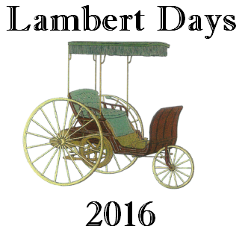
Mike Dull (419) 203-3484

Pageant

Laura Morgan (419) 965-2515

Cruise-In & Car Show

Jan Osborn (419) 605-5412

Craft and Vendor Show

Laura Morgan (419) 965-2515

Corn Hole

Josh Agler (567) 259-9941

Donations

Steph George (419) 965-2428

Thursday, July 14th
7:00 pm Lambert Days Pageant
Cake and Ice Cream Following
Friday, July 15th
3:00 pm Craft and Vendor Show
4:00 pm Steak Dinner (Carry-out available)
5:00 pm Flag Rising Ceremony
Harvey Lewis Post 346
5:00 pm Kid’s games and inflatables
6:00 pm Kid’sWiffleball Homerun Derby
6:00 pm Music by: “Jeff Unterbrink”
7:00 pm Texas Hold ‘em
7:00 pm Adult Wiffleball
8:00 pm Monte Carlo Night
9:00 pm Rock Band: “Bydus”
10:15 pm FIREWORKS!!
Fireworks rain date Saturday night

Saturday, July 16th
8:00 am Men’s Slow Pitch Softball
9:00am Co-ed Rec. Volleyball
10:00 am Kid’s Wiffleball Tournament
11:00 am Kid’s games and inflatables
11:00 am Craft and Vendor Show
12:00 pm Corn hole Registration
1:00 pm Corn hole Tournament
1:00 pm 3x3 Basketball
4:00 pm Hog Roast (Carry-out available)
4:00 pm Music by: “Cass Blue”
5:00 pm Bingo
6:00 pm Music by: “Adam Andrews Blues Band”
7:00 pm Adult Wiffleball
9:00 pm Rock Band: “Nut Flush”
Dusk Kid’s Movie under the Stars

Sunday, July 17th
9:00 am Softball continues
10:00 am Car Show Registration
10:00 am Craft and Vendor Show
11:00am Chicken BBQ (Carry-out available) Dinner music provided by:
“Triad”
12:00 pm Car Show
12:00 pm Kid’s games and inflatables
1:30 pm Car Show Judging and Awards
1:45 pm Parade Line-up
3:00pm 49th annual Lambert Days Parade

Activities continue at the park after the parade

See ya 2017!!

